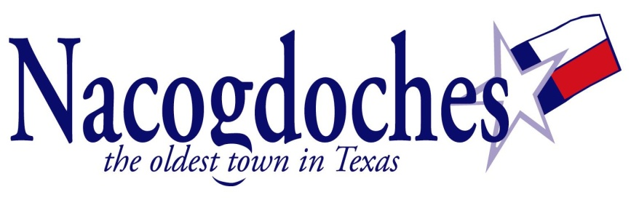
NEWS RELEASE

For Immediate Release: Contact information: Mercedes Franks
April 27, 2018 (936) 559-2970

Computer Classes at the Public Library

(Nacogdoches, TX) – The Nacogdoches Public Library announces its computer class schedule for April 2018. Computer Basics, which teaches mouse skills, copying, pasting, and basic Internet searching, will be May 2nd at 4:00 pm. Microsoft Excel I and II will be offered May 15th and May 22nd from 5:30-7:30 pm. Classes are free, but registration is requested. Please call 559-2970 to register.

(30)

