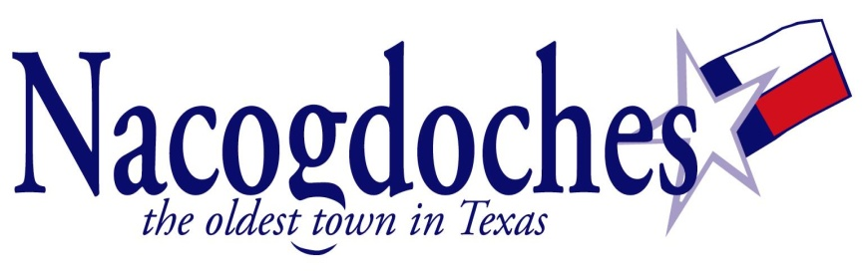
NEWS RELEASE

For Immediate Release: Contact information: Mercedes Franks
April 27, 2018 (936) 559-2970

Mi Cocina Latina: Polvorones de Canela (Mexican Cinnamon Cookies)

(Nacogdoches, TX) – Library staff will offer a free baking class on Friday, May 4th at 6:30 pm. Participants will learn to make polvorones, traditional Mexican cinnamon cookies. The class will feature a demonstration and participants will be able to take home a sample to complete at home. Registration by May 3rd is required. Please call 559-2970 or register online by visiting www.ci.nacogdoches.tx.us/library.

(30)

